**Automated Testing using Matillion job**

* Data load from each source to target is checked **using one metadata driven reconcile job**.
* For any Source A mapped to be loaded to Target B, it is **checked if there is any record present in A which is not loaded in B**. Such scenario is only **expected to happen in case there is any invalid record in A** that did not pass the data quality check.
* The **source to target mapping is stored in a mapping table in Snowflake**, along with a query to check the data load, and the view name that stores invalid records of Source.
* Every time this reconcile job is ran, **the source information, target information, query to check the load from source to target, and the record count of the view containing invalid records are fetched** and stored in another Snowflake Table

The Source Mapping Table:

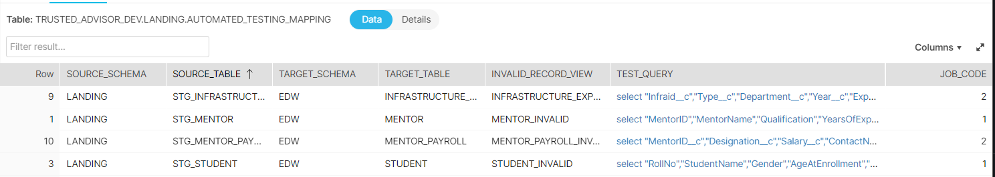

Reconcile job in Matillion:

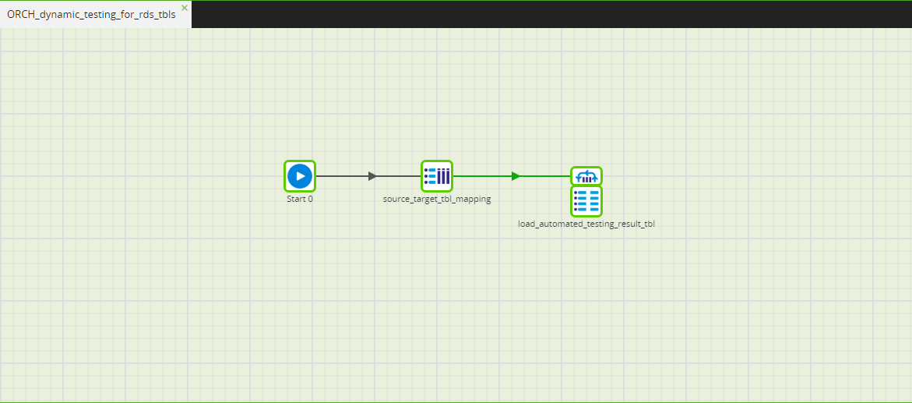

Target Results Table:

